What to Expect During a Snow Storm
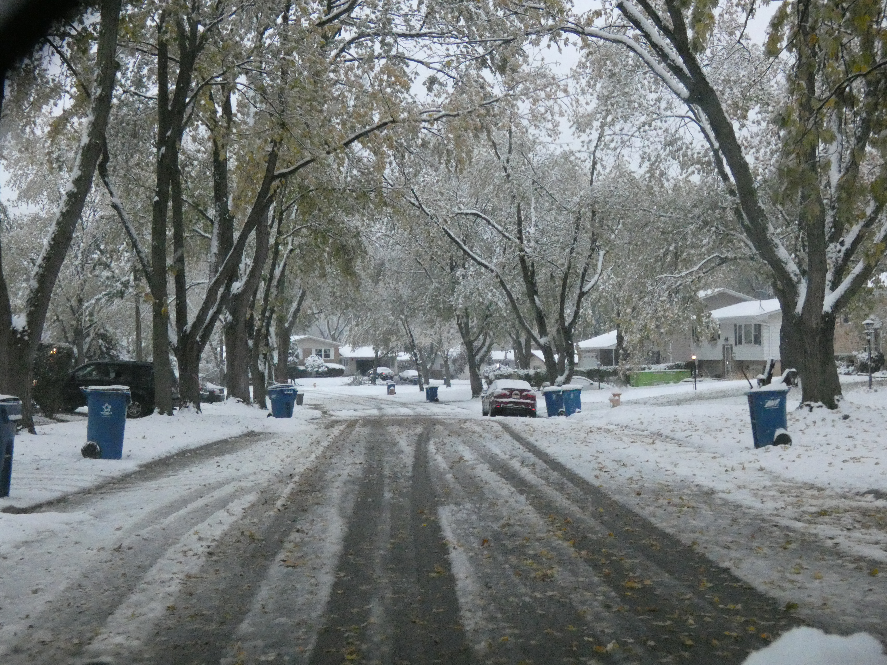
Our snow & ice fighting program’s top priority is to keep people safe and roads passable. Our staff attends training to keep up with best practices for using the right amount of salt to keep roads safe while also reducing our impact on the environment. Because the conditions of each storm are different, we have a plan and decision-making process to make the best use of finite staffing and equipment.
During a storm, what do we plow first?
In general, we have prioritized high-volume roadways and access to hospitals, police stations and fire stations. After we clear these routes, we plow secondary roadways and then neighborhood streets and cul-de-sacs.
Depending on the rate and duration of snowfall, salt may at first only be applied to intersections or other high-risk areas, like bridges. Salting the other roadways during our second pass makes sure the salt is not plowed off the road before it has a chance to work. After the storm has passed, crews work to clear snow from shoulders and street corners.
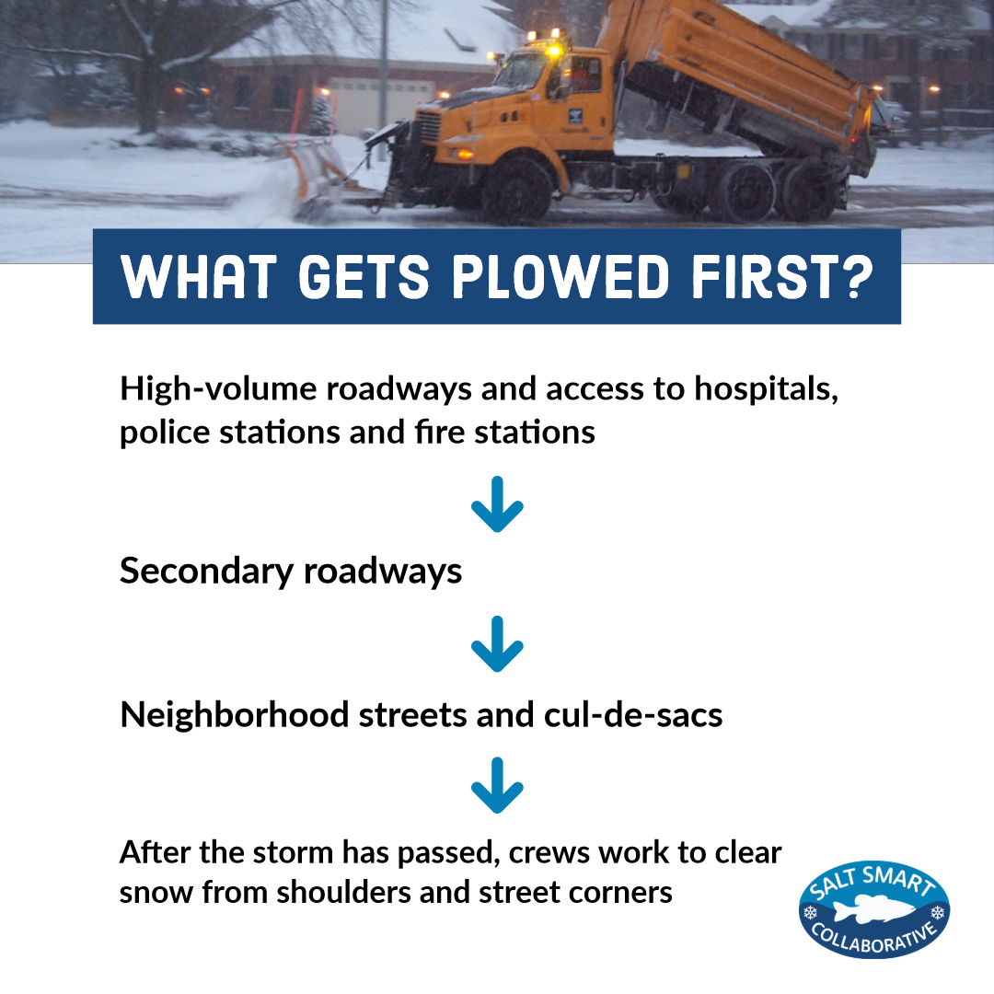
To help us do our job better, please:
- Do not park on the street after a 2” snowfall.
- If possible, stay home during a snow storm. If you have to go out, give yourself extra time and drive slowly.
- Don’t Crowd the Plow – give plows extra space on the road and do not pass.
- Remember not to shovel plowed snow back onto street – it is illegal and unsafe.
- Clear snow from fire hydrants for easy access.

