This Fall, Use Leaves as a Resource!
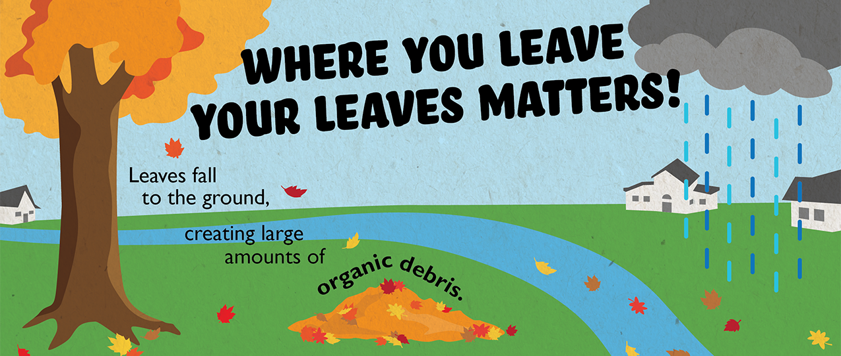

As fall rolls around, colorful leaves begin to fall off their trees and scatter lawns across the neighborhood. Extra clean-up is needed in the fall to keep your yard tidy as the leaves pile up.

When cleaning up your yard, it is important to dispose of your leaves the right way! Many times, leaves end up on the street where they can be washed into storm drains, back up stormwater and enter our waterways where they can cause big problems such as contributing to algae growth.

Three Ways to Take Care of Fall Leaves
1. Mulch
Mulching leaves can be a great way to take advantage of all the nutrients in leaves. Mulching your leaves can be done by simply mowing them along with your grass and allowing the resulting material to work its way into the lawn. The shredded leaves, along with the grass clippings, create a great combination of nutrients, including phosphorus and nitrogen, which can naturally fertilize your lawn. This works best if you do not have a large amount of leaves.
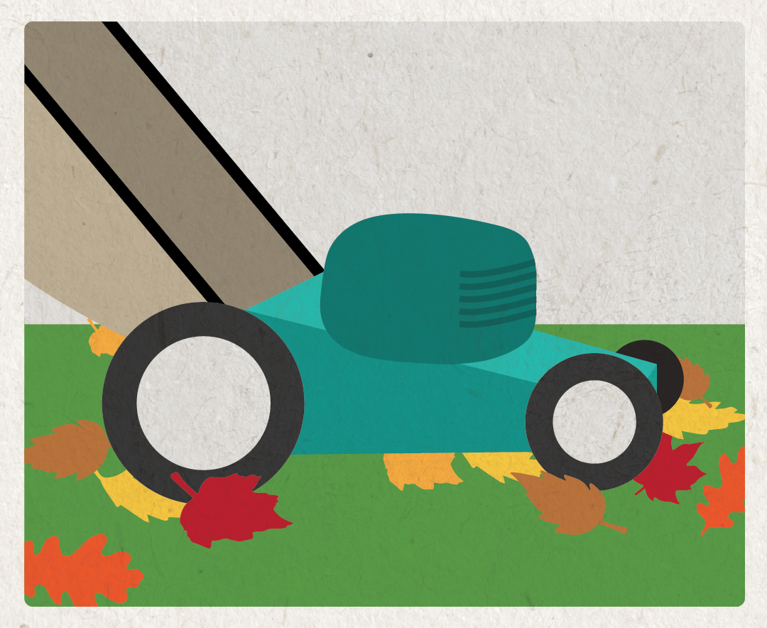
2. Compost
Composting your leaves is a great and inexpensive way to dispose of your leaves in a way that will benefit your gardens and flowerbeds. When leaves decompose they create a nutrient rich compost that will increase the quality and fertility of your soil.
Leaves generally take a long time to decompose--mulching them first will quicken the decomposition. Simply collect the mulched leaves with your bag attachment on your lawn mower and either cover your flower beds and garden or store in a compost bin for use next year. In the spring, incorporate the decomposing leaves into the soil and you are ready for planting!
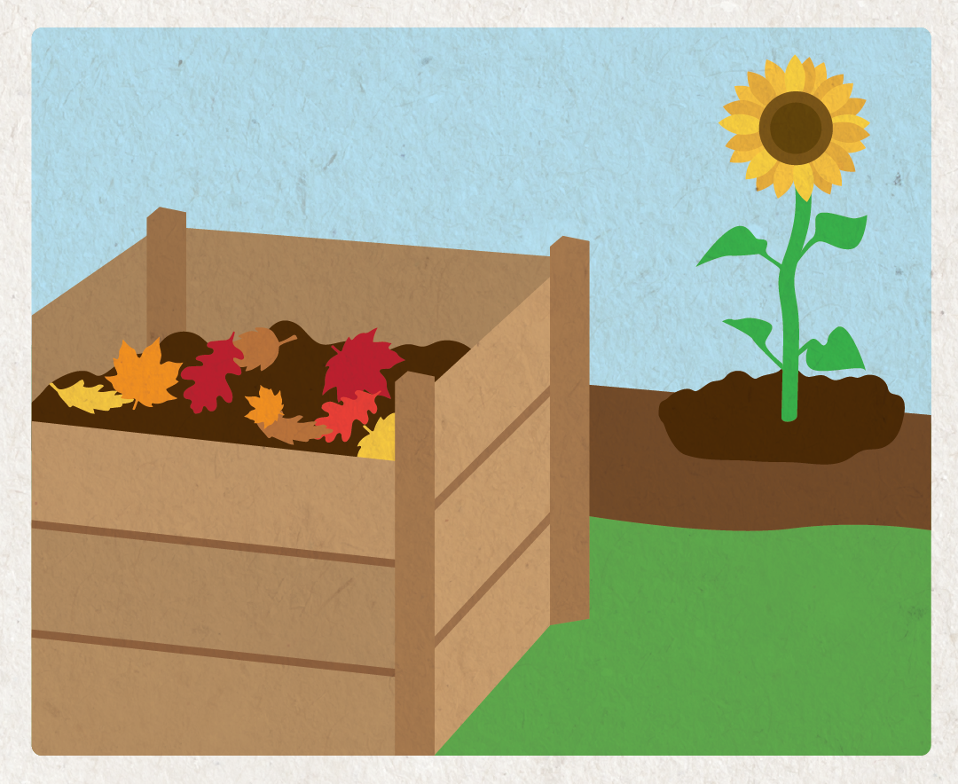
3. Bag of Rake to the Curb
Take part in your community’s leaf collection program. Check your community’s website to learn about how and when leaves will be collected in the fall. Bagged or raked to the curb, just keep them out of the street!
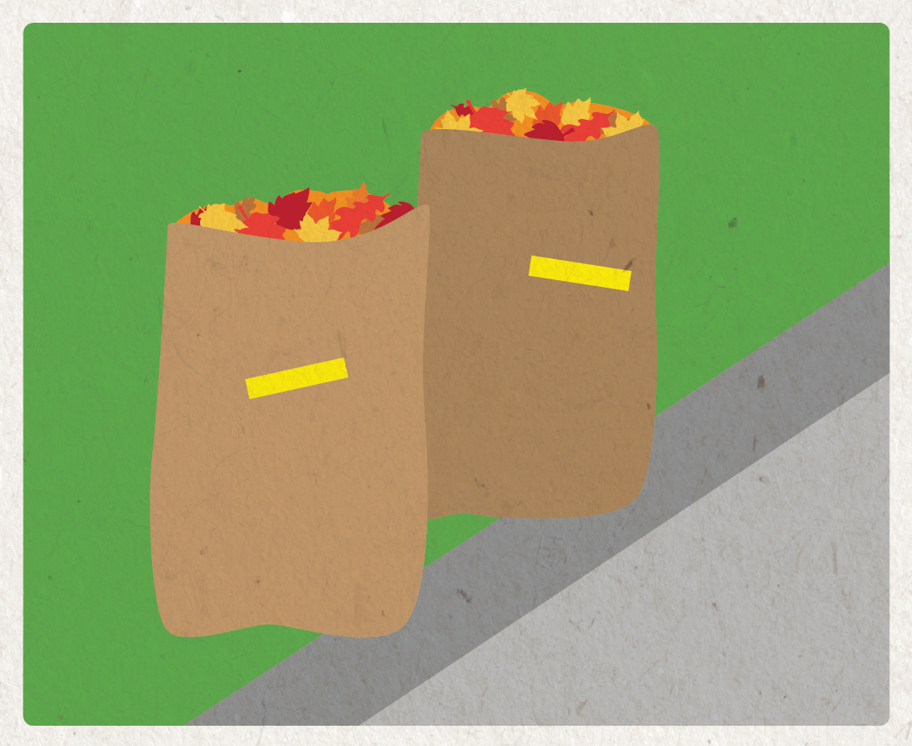
Many community leaf collection programs ask that you bag your leaves and place them by the curb.
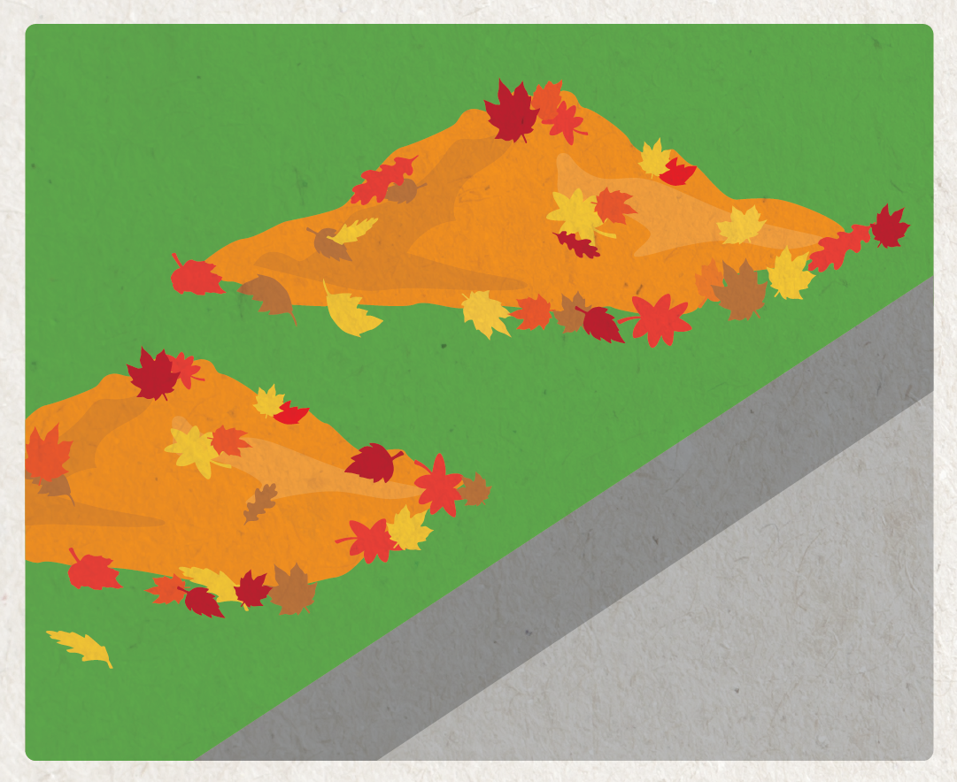
And some communities require you to rake leaves to the curb, but not into the street!

While raking leaves in your yard, be sure to rake leaves out of the street as well, especially before a storm. Taking care of leaves properly keeps our community looking good and prevents loose leaves from causing problems in our storm drains and local waterways. By taking care of our leaves responsibly, we can keep our yards and rivers healthy and beautiful.

