The Effects of Leaves on Storm Drains
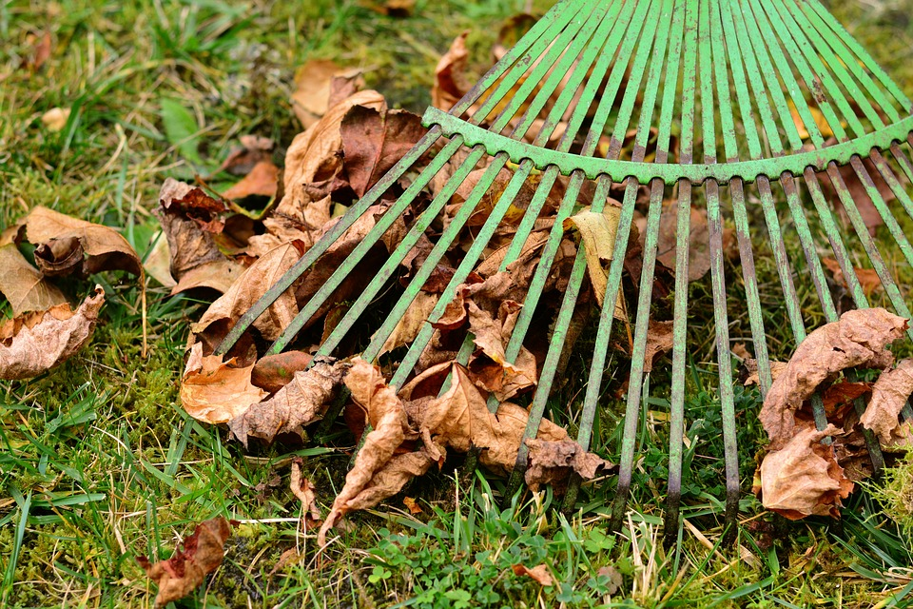

We all enjoy the bright colors of changing fall leaves. And when leaves litter our lawns, we might complain about having to continuously rake them. But how many of us make the connection that leaves impact stormwater systems and the health of local waterways?

How Leaves Cause Problems for Local Drainage Systems﻿

During and after rainfall, stormwater brings leaves that have gathered on streets and sidewalks into storm drains. When large amounts of leaves collect in storm drains, leaves can cause trouble for homeowners, stormwater systems, and water quality. The leaves can mat across the storm drain and block water flow, causing water to back up on the street and possibly into nearby basements.
2 Main Problems:
1. Residential Flooding
During a storm, keeping your home free of water is a big concern for homeowners. When leaves clog up storm drains, it can become difficult for stormwater to properly flow through. Storm drain backup is a common cause of lawn and basement flooding, which can affect homeowners repeatedly if storm drains are not regularly cleared. As residents, your help is needed to help prevent localized flooding due to blocked storm drains.
2. Poor Water Quality
As the rain falls and flows through the piles of leaves, phosphorus quickly leaches out of leaves much like a tea bag in water. This “leaf tea” makes it way to our local waterways through the stormsewer system. Too much phosphorus in our water causes unsightly and potentially dangerous algae blooms, turning the water green and smelly while lowering oxygen levels in the water. This is bad for the plants and animals that live in our streams as well as for people, especially if the waterway is used for public water supply or for recreation.

This Fall, Keep Storm Drains Clear of Leaves

﻿
While you are raking leaves in your yard, be sure to rake leaves out of the street as well, especially before a storm. By disposing of leaves properly this fall, we can maintain the water quality and health of our local waterways. Storm drains are a crucial part of the stormsewer system--it is important to keep them clear of leaves and any other debris. Even if you do not live next to a waterway, leaves that pile up in your street and storm drain will end up impacting nearby waterways.
Taking part in your community’s leaf collection program can be an easy way to dispose of any unwanted leaves on your yard! Simply check your community’s website for designated pickup days and instructions. Bagged or raked to the curb, keep the streets free of leaves to help protect local water quality and prevent street flooding.

