The Connection Between Leaves and Water Quality
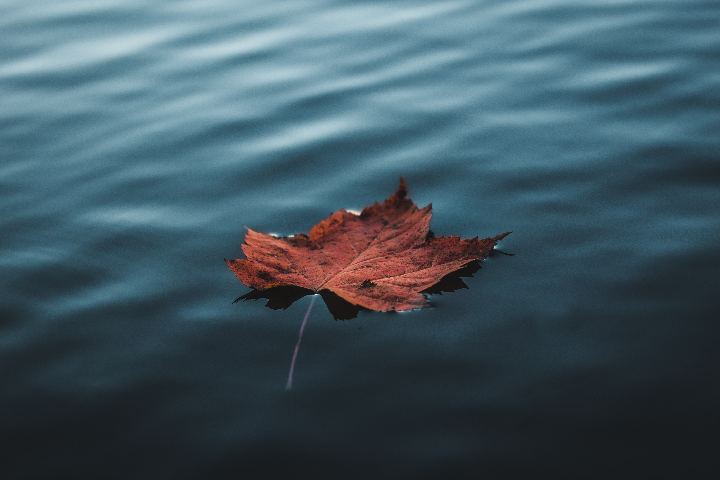
Colorful leaves create beautiful scenes in our neighborhood throughout the fall season but quickly pile up in yards and streets. Did you know that fall leaves contribute up to half of the annual amount of phosphorus in urban stormwater in just the months of October and November?
As the rain falls and flows through the piles of leaves, phosphorus quickly leaches out of leaves much like a tea bag in water. This “leaf tea” makes its way to our local waterways through the stormsewer system. Too much phosphorus in our water causes unsightly and potentially dangerous algae blooms, turning the water green and smelly while lowering oxygen levels in the water. This is bad for the plants and animals that live in our streams as well as for people, especially if the waterway is used for public water supply or for recreation.

How Does Phosphorus and Algae Harm Water Quality? ﻿

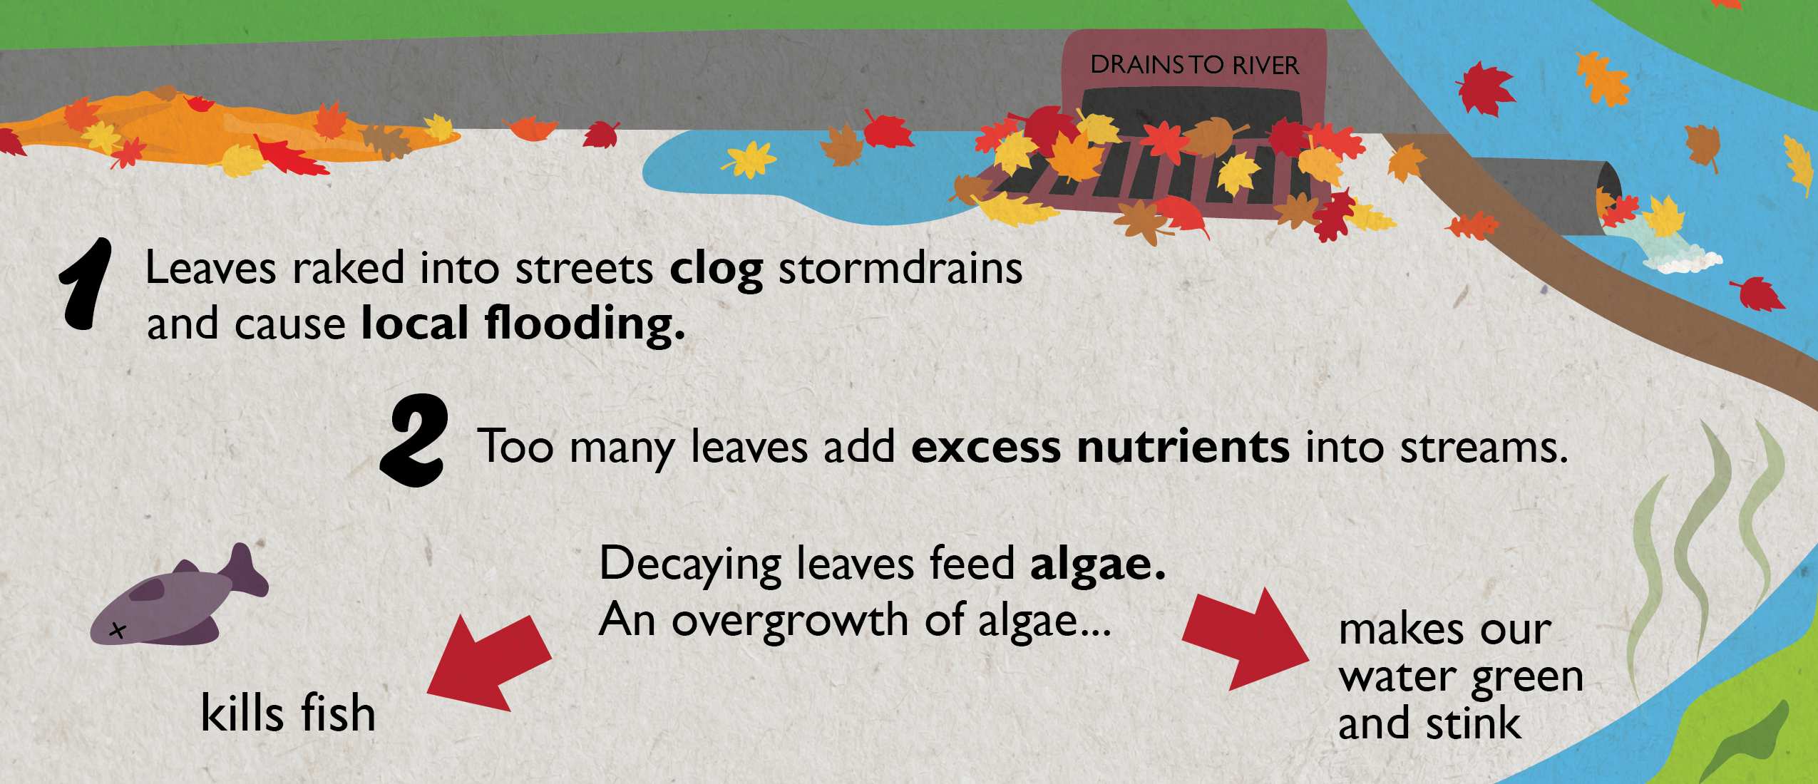
1. Lowers Oxygen Levels
High levels of phosphorus feed algae, causing it to grow very quickly and “bloom” across a lake or stream. As algae grows and then dies, it pulls large amounts of oxygen out of the water. This lack of oxygen, even for short periods, impacts aquatic life like fish and macroinvertebrates (the bugs that live in the water).
2. Blocks Sunlight
Aquatic plants depend on sunlight for survival. When a layer of algae begins to cover the surface of the water, it becomes difficult for sunlight to penetrate the surface and reach aquatic life.
3. Lowers Oxygen Levels
Algae growth can lead to unpleasant sights and conditions in our local waterways. Algae grows to form a foul smelling, green layer of muck on the surface of the water. These conditions can affect property values and negatively impact recreational activities.
4. Impacts Drinking Water
Large algae blooms around public drinking water intakes can make the water taste and smell bad. The water requires extra treatment, which is more expensive. Harmful Algae Blooms caused by blue-green algae can shut down a public water supply system for days until it can be cleared out of the system.
5. Harmful Algae Blooms
Harmful Algae Blooms (HABs) are caused by certain species of blue-green algae that give off harmful toxins. Excess phosphorus feeds the blue-green algae causing it to “bloom” across a waterway. These Harmful Algae Blooms usually occur in lakes or slow moving water and have been linked to serious health issues in people and even death in dogs, cattle, and other wildlife.
It is important to note that most algae does not create these toxic conditions. Check out this link to find out more about HABs in Illinois: http://www.dph.illinois.gov/topics-services/environmental-health-protection/toxicology/habs
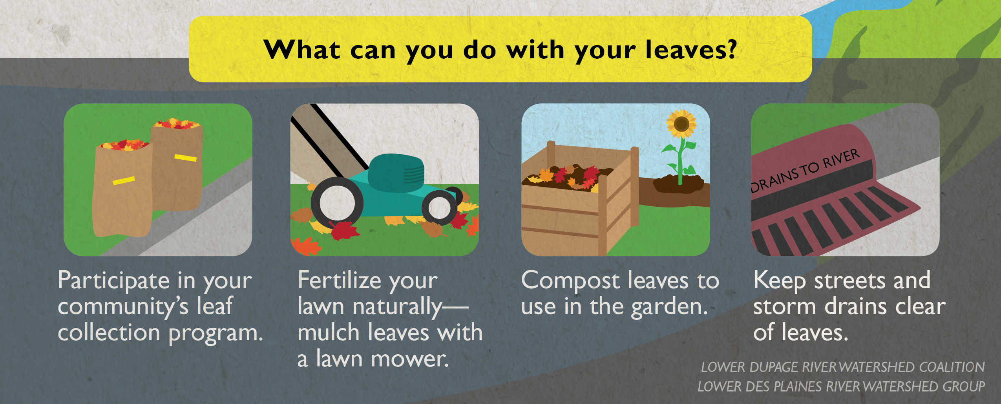
Timing is everything! Removing leaves from the street before it rains can reduce the amount of phosphorus in urban stormwater by as much as 80%, according to a recent study in Madison, WI. Follow your community’s leaf collection program to dispose of leaves properly. Bagged or raked to the curb, keep the streets free of leaves to help protect local water quality.

Resources
﻿"Harmful Algal Blooms," U.S. Environmental Protection Agency, https://www.epa.gov/nutrientpollution/harmful-algal-blooms
"Leaves," Clean Lakes Alliance, https://www.cleanlakesalliance.org/leaves/﻿

